**Kimmen Plumbing & Heating, Inc.**

415 South Dartmouth Lane

Altoona, PA 16602

814 942-8529

**Furrer Beverage**

132 Stroehman Road

Altoona, PA 16602

814-944-4695

**Pacifico & Sons Bakery**

1208 Fifth Ave

Altoona, PA 16602

814-943-3663

**Advance Auto Parts**

631 Pleasant Valley Blvd

814-949-9721

320 West Plank Road

814-941-4490

**Allegheny Glass & Mirror**

701 Tenth Ave

Altoona, PA 16601

814-946-1546

**Pleasant Valley Animal Hospital**

D.A. Stachmus, D.V.M.

808 Pleasant Valley Blvd.

Altoona, PA 16602

814-946-0010

Office Hours by Appointment Only

**First Stop Shop**

Discount Grocery Outlet

1815 Union Ave.

Altoona, PA 16602

814-944-3479

**Spherion**

3515 Sixth Ave

Altoona, PA 16602

814-942-1199

***Please Patronize Our Sponsors***

*Additional Sponsorships Available*

*Please Contact Frank Goss @ 329-6094 if you*

*Would like to sponsor our newsletter.*

*PLEASE DIRECT ALL BUILDING & HALL RENTAL INQUIRIES TO TERRY ANDERSON*

*814-932-0465*

**Finelli’s Italian Villa**

1808 4th Ave.

Altoona, PA 16602

(814) 943-8510

***Please Patronize Our Sponsors***

*Additional Sponsorships Available*

*Please Contact Frank Goss @ 329-6094 if you*

*Would like to sponsor our newsletter.*

*PLEASE DIRECT ALL BUILDING & HALL RENTAL INQUIRIES TO BROTHER TERRY ANDERSON*

*814-932-0465*

Knights of Columbus

Non-Profit Organization

**U.S. POSTAGE**

**PAID**

Permit No. 15

Altoona, PA

PO Box 711

Altoona, PA 16603

Address Service Requested

***Knights of Columbus***

***Altoona Council #551***

***1508 12th Ave***

***Altoona, PA 16601***

***814-942-6262***

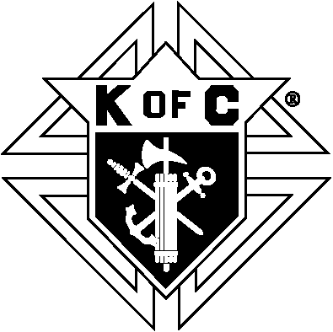

*\*\*\*NEXT MEETING TBD\*\**\*

***Note: Meetings Suspended During Covid-19***

**August 2020**

**Volume 19, Issue 5**

The Anchor 

**Knights of Columbus – Council 551**

## Grand Knight’s Message

***Council Officers***

***Grand Knight***

Terry Anderson

***Deputy Grand Knight***

Mike Moloney

***Treasurer***

Rick Tomlinson

***Recorder***

Kevin Byrne

***Financial Secretary***

Frank Goss

***Chaplain***

Msgr. Robert Mazur

***Chancellor***

Ray Kelly

***Advocate***

Bill Crawford

***Lecturer***

Dennis Meyers

***Warden***

Mike Miller

***Guards***

Mike O’Connor

Pat Burn

***Trustees***

Joe O’Leary

Paul Kowalski

Shawn Kelly

***COUNCIL NEWS (CONT’D)***

**“Joseph D Tomlinson Memorial Scholarships”**

We awarded eleven scholarships totaling $5,200.00 from our Joseph D Tomlinson Memorial Scholarship fund. Ten of scholarships were awarded to students entering Bishop Guilfoyle Catholic High School and one to a student attending Saint Francis University. To date we’ve provided over $26,000 in scholarships over the last four years. This scholarship recipients are: Elina Casanave, Alyssa Franks, Joe Hofer, Christopher Kozminski, Emily Miller, Evan Rimbeck, Aurik Steinbauer, Finley Steinbugl, Marco Swope, Katie Zerbe, and Cristofer Diaz.

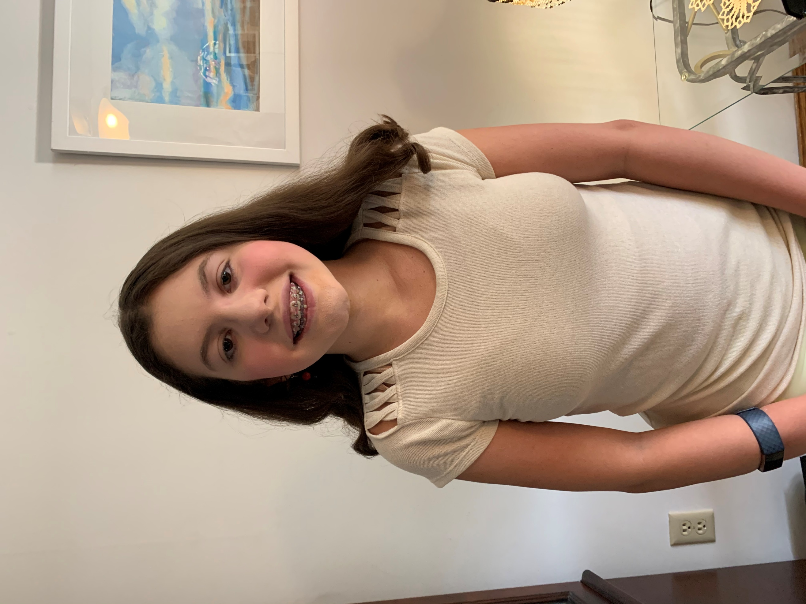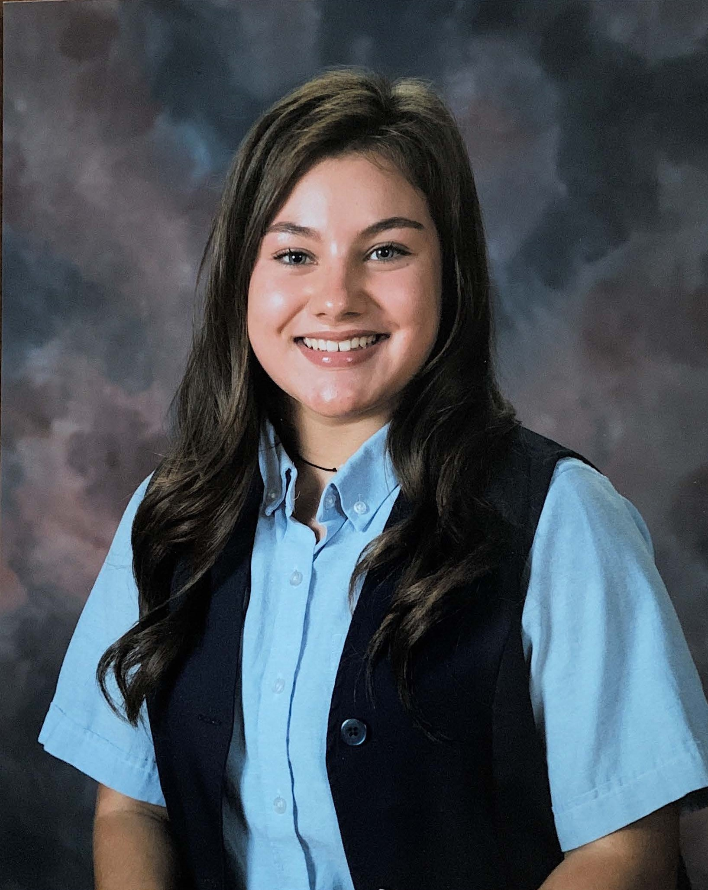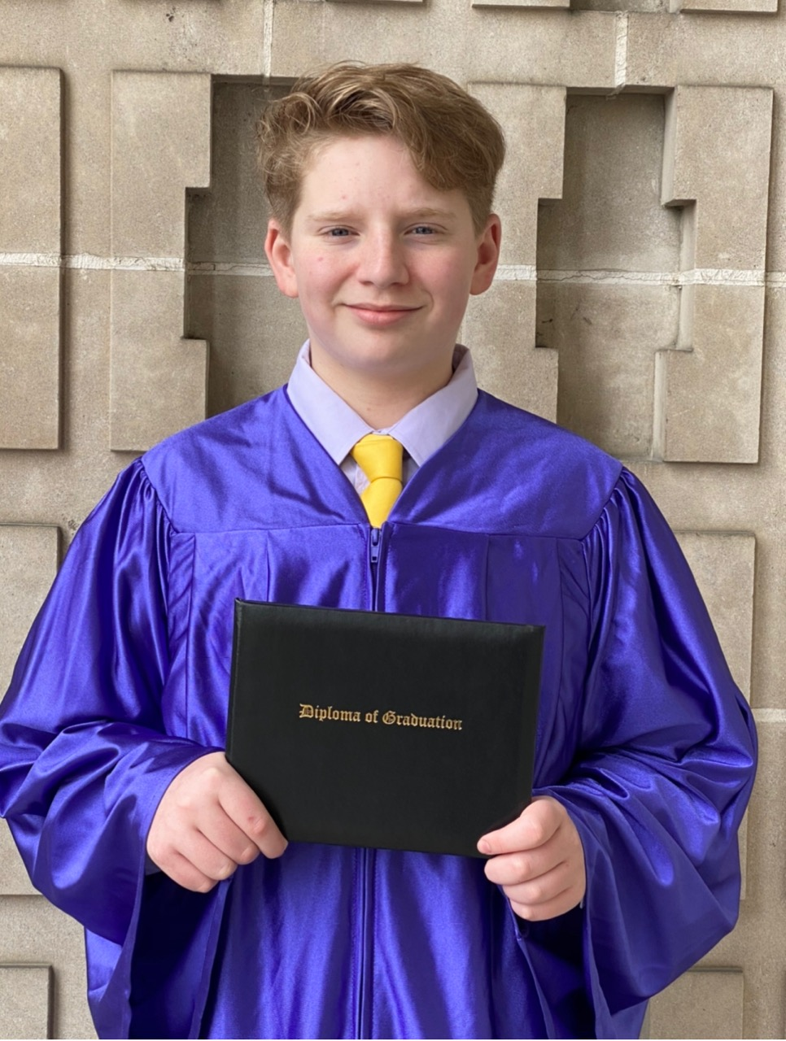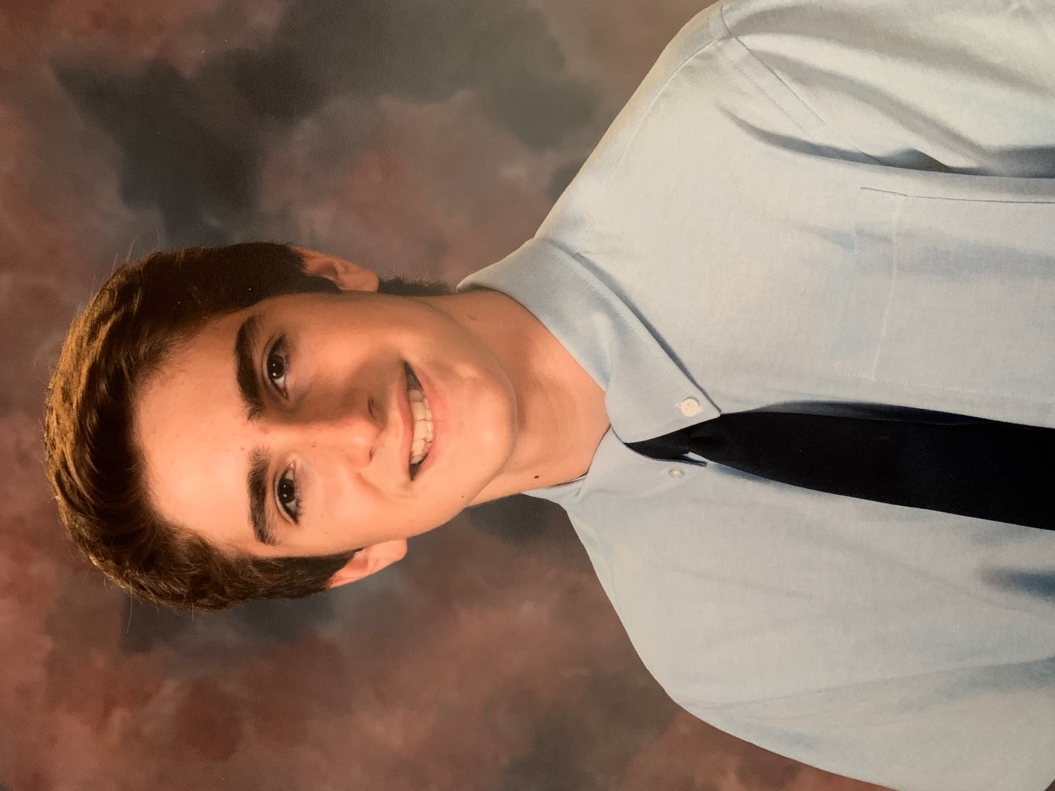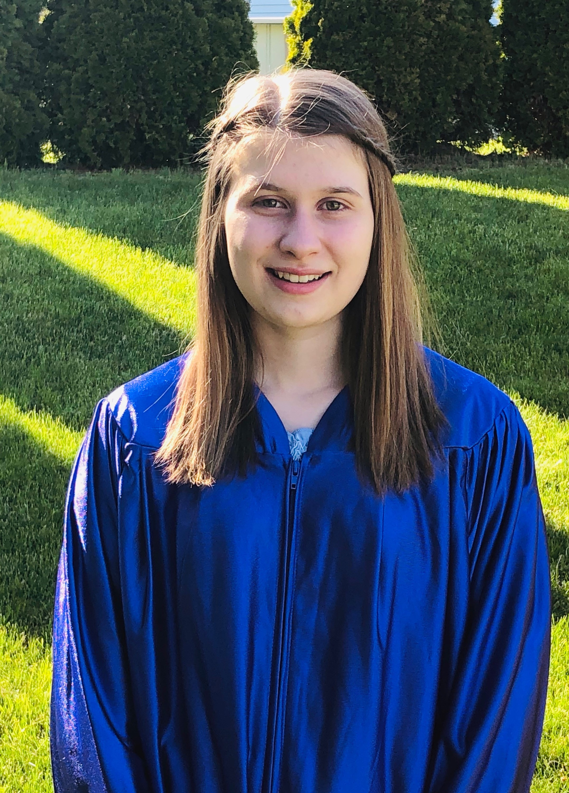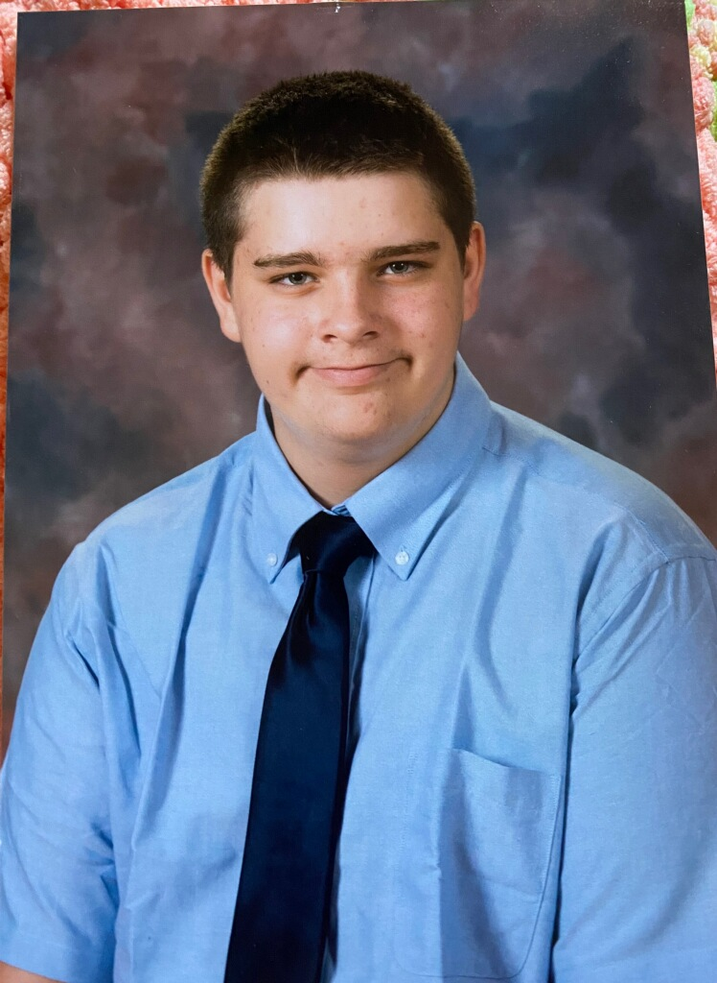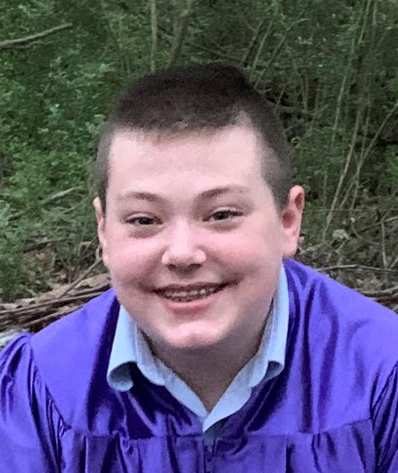

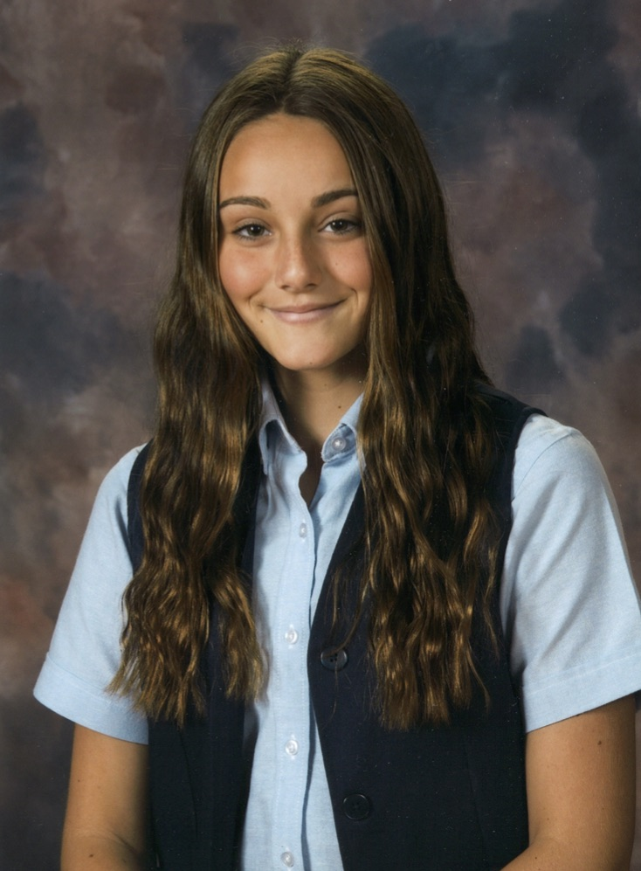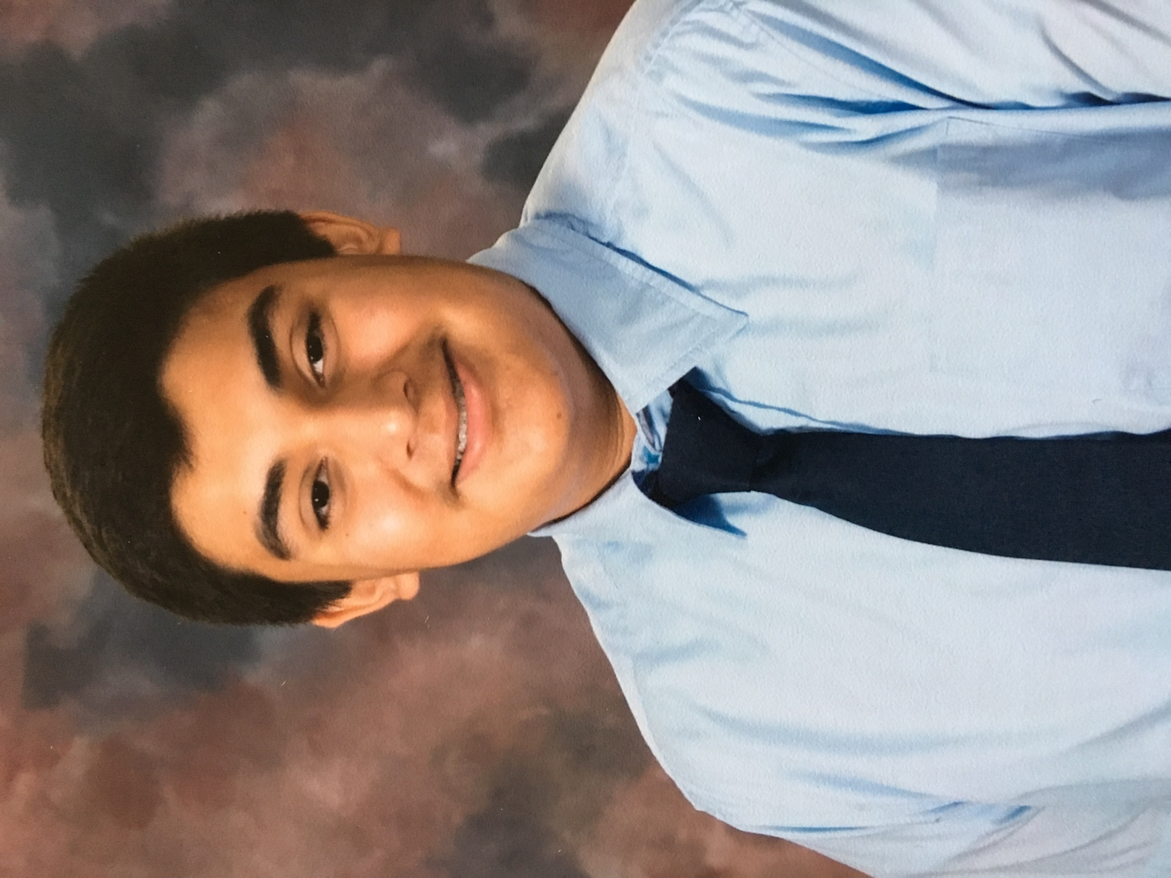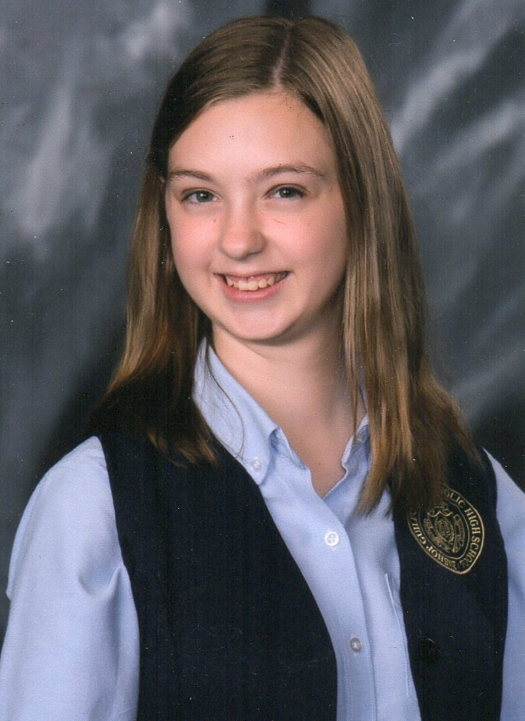

**“Council Meetings”**

The monthly council meeting for September is canceled due to the current restriction on inside group gatherings. Please continue to check the council website and Remind notifications for important council information.

***MEMBERSHIP***

A council is only as active and effective as its members. So, if you know someone who would be a great addition, please have them sign up at [www.kofc.org/joinus](http://www.kofc.org/joinus). Right now, the Supreme Council will pay the first-year dues for every new member who joins online. Enter the code **MCGIVNEY2020** to take advantage of this special offer. We can hold an Online Exemplification Degree for any prospective members.

***COUNCIL UPCOMING EVENTS***

**“Nite at the Races”**

Due to the current Governor’s mandate we have decided to cancel this event. We are considering some other options for a fundraiser in the fall. If you have any ideas for fundraisers that can be conducted under our current restrictions, please reach out to Grand Knight, Terry Anderson, at [kofc551@gmail.com](mailto:kofc551@gmail.com).

**“Event Reminders”**

To receive reminders of Council events, on your mobile phone, go to your app store (Apple App Store, Google Play Store, etc.) and download the Remind: School Communication app. Create an account using your mobile phone, email, or Gmail account. Once logged in send a txt with the message **@kofc551** to **81010**. You will get notified of being registered. Or, email your mobile phone # or email to [kofc551@gmail.com](mailto:kofc551@gmail.com) with the subject “Remind” and I can add you manually.

My Brother Knights,

Short and sweet this month so I can save room for all the news. The pandemic is certainly wreaked havoc on our getting together, but we have still managed to gain some new members and contribute to our mission of charity. Keep checking the website, [www.kofc551.org](http://www.kofc551.org) for continued updates and news. Additionally, I’ll be sending out important updates and reminders via our Remind notification.

Fraternally,

TA

Not pictured: Cristofer Diaz

## Council News

**“Joseph D. Tomlinson Memorial Golf Tournament”**

We were fortunate to be able to hold our Joseph D. Tomlinson Memorial Golf Tournament. I am extremely proud of our members and volunteers who helped put the tournament on after a late decision to continue with it after the county went “green”. The short time to put it on made it difficult to advertise, communicate with our usual sponsors, and solicit donations. As a goodwill gesture to all our sponsors and donors, we placed signs out on the course regardless of whether they were able to sponsor or not. Additionally, we will place an ad in the Altoona mirror thanking all our donors and sponsors that have continually supported us and urging people to please patronize them during this difficult time.

This year’s winning team was comprised of Andrew Myers, Dianne Myers, Mike Miller, & JJ Vasilko, who was also our winning team in 2019. Congratulations!

District/State News

***District Deputy News***

As some may know, Council 551 was slated to host the PA Knights of Columbus Central East caucus meeting on Sunday, September 13th. With the recent announcement from Governor Tom Wolfe limiting indoor groupings to 25 people or less, the decision was made to cancel the live event and switch to a virtual one. Details have not been shared about the event yet, so stay update by checking the Council website and Remind notifications. If it’s postponed later into September or later it will be in the next Anchor as well.

***UPCOMING EVENTS***

**SEPTEMBER 3rd monthly meeting is canceled**

**October 31 – Fr. Michael J. McGivney’s Beatification**